# **Squeeze and Excitation Networks**

"Squeeze and Excitation Networks (SENet)" is a model architecture that introduces a novel SE module designed to enhance the performance of convolutional neural networks (CNNs). The primary novelty of SENet lies in its attention mechanism, which allows the network to adaptively focus on informative features while suppressing less relevant ones by applying additional weights to channels.

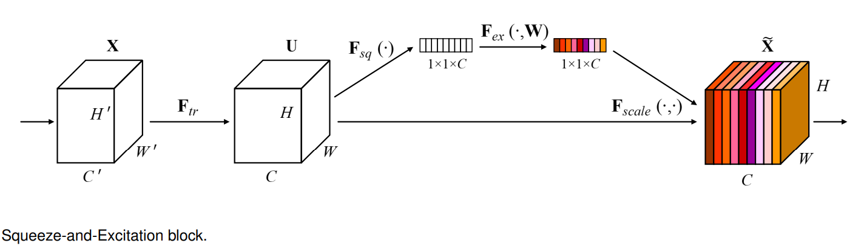

**Key Novelty:**

1. **Channel-Wise Attention:** SENet introduces a channel-wise attention mechanism that captures interdependencies between channels within a feature map. This is achieved through a "squeeze" operation, which compresses spatial information into channel-wise statistics, and an "excitation" operation, which learns a set of channel-wise weights to emphasize important features.
2. **Adaptive Feature Recalibration:** The network dynamically recalibrates its feature maps based on their importance, allowing for better utilization of relevant information during the training process. This adaptability enhances the model's ability to discriminate between features and improves overall performance.
3. **Integration with Existing Architectures:** SENet is designed to be seamlessly integrated into existing CNN architectures without requiring significant modifications. This facilitates the adoption of the proposed attention mechanism in various deep learning applications.

**Drawbacks:**

1. **Computational Overhead:** One drawback of SENet is the additional computational cost introduced by the channel-wise attention mechanism. The squeeze and excitation operations may increase the overall computation time during both training and inference phases, particularly in scenarios where computational resources are limited.
2. **Increased Model Complexity:** The incorporation of SENet adds complexity to the overall model architecture. This complexity might make the training process more challenging and necessitate careful hyperparameter tuning to achieve optimal performance.

In summary, Squeeze and Excitation Networks contribute a novel attention mechanism to improve the performance of CNNs by dynamically recalibrating feature maps. Potential drawbacks being increased computational overhead and model complexity, when considering its adoption in practical applications.